

|  |
| --- |
| Volunteering Awards 2025 |
| Stakeholder Communications Pack |
|  |

## Purpose

This communications pack includes text and images to help you share information about the 2025 Volunteering Awards and encourage nominations.

The pack includes copy for newsletters and social media channels.

## EDM / Newsletter item

**Subject line:** 2025 Volunteering Awards nominations now open

**Preview text:** Recognise an outstanding volunteer or organisation today

Do you know an inspiring volunteer or volunteer involving organisation?

Now is your chance to recognise their impact by nominating them for the 2025 Volunteering Awards.

**About the Awards**

Volunteers play a vital role in Victoria. They help us build vibrant, connected communities where everyone is included.

The Volunteering Awards are a chance to celebrate the contributions of volunteers across the state.

There are 4 categories for individual volunteers and 4 for volunteer-involving organisations.

Each category reflects the varied ways volunteers can make a positive impact on their communities.

**How to nominate**

Nominations close **Friday 4 July 2025**.

Find out more and nominate [link: <https://www.volunteeringvictoria.org.au/awards/>].

**Image:**   
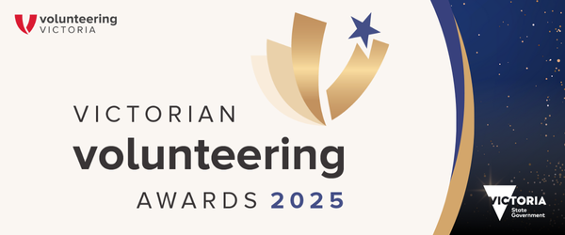

## Social Media

|  |  |  |
| --- | --- | --- |
| Channel | Text | Tile |
| Facebook / LinkedIn / Instagram  Date recommended: From 29 April 2025 | Nominations for the Victorian Volunteering Awards 2025 are now open!  The awards are a great opportunity to acknowledge the incredible contributions volunteers make to our communities.  If you know a deserving individual volunteer or community organisation, help celebrate the important contribution they make by nominating them for an award.  To nominate, visit: <http://volunteeringvictoria.org.au/awards>  [Instagram: To nominate, visit the Volunteering Victoria website.]  Anyone can nominate! Submit an individual or an organisation for their contribution and impact on Victorian communities. Nominations close Friday 4 July.  The awards are delivered by Volunteering Victoria, with the support of the Victorian government, to recognise the outstanding volunteers around the state.  #VicVolAwards2025 | Picture 106918246, Picture  **Alt-text:**  Text on abstract blue and cream background with gold touches and logo. Text says: Victorian Volunteering Awards 2025 – Nominations open! - volunteeringvictoria.org.au. Volunteering Victoria and Victorian government logos at bottom. |

## Logo

**Main logo: White logo (for dark backgrounds):**

